Summer Term - Year 1

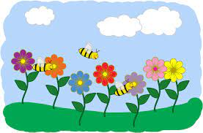

Welcome back! We hope you all enjoyed the Easter holidays and didn’t eat quite as much chocolate as the children did!

READING AND SPELLINGS
A continued BIG thank you to everyone who has been signing reading diaries regularly - we really notice a difference. The children are constantly picking up new sounds and forming them into more complex words and regular reading will really help with this. It’s wonderful to hear the progress that the children have made and we are hoping to encourage them to read their books for the whole class to build their confidence and use of expression.

We have sent home the spellings for this half term. A copy of the spelling sheet is on our class webpage - just in case...!

PHONICS SCREENING CHECK
Just to remind you that the National Year 1 Phonics Screening Check will be taking place during the week of June 12th. It is vital your child attends school that week, however, if your child is ill enough to stay at home during that week, we would appreciate it if you would contact the school as early as possible and we can make alternative arrangements - Mr Matthews cannot authorise any absences during that week.

P.E KIT and SWEATSHIRTS
Please make sure P.E kit (named) is in all week for our lessons. Some of our P.E lessons will be outside now (weather permitting!) so please ensure your child has trainers/pumps which fit them and has their name written inside. It would also be appreciated if all sweatshirts could be named as this will save many arguments after playtime and P.E! Please could you also make sure that if your child has long hair it is tied back for each lesson.

SUMMER ESSENTIALS
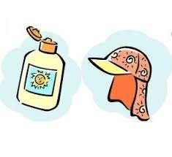
Fingers crossed the weather is getting better and we will
see lots of sunshine! Please make sure that your child brings
in a fresh water bottle everyday and a sunhat. Sun-cream
is best put on at home and should last for the day. Children
can bring sun-cream into school when it is really hot but
they will need to apply it themselves.

GARDENER’S WORLD/ALL CREATURES GREAT AND SMALL
These will be our main science topics throughout the next term. The children will have the opportunity to visit the school garden, plant seeds and spend time hunting for bugs! We are going on a spring walk which will give us the chance to look at seasonal changes and hunt for signs of spring. We will be looking at a variety of different animals and will find out what they like to eat, where they like to live and how we can look after them. We are also hoping to plan an exciting trip later in the term.
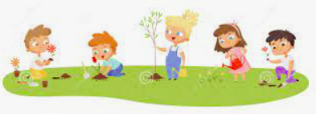
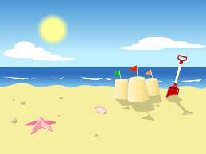
OH I DO LIKE TO BE BESIDE THE SEASIDE!
This will be our history topic this term. The
children will find out what seaside holidays were like in the
past. They will be comparing what it is like to live by the
seaside with what it is like to live in the countryside. We are
also finding our about ‘Our Home Town’ in geography and will be going on a walk to Whitcliffe Common to look for the physical and human features of Ludlow.

SCHOOL WEBSITE
We hope some of you have been able to visit our school website over the past term and seen some of the things that have been happening in the classroom. We will continue to share photographs and class documents for your information.

GENTLE REMINDER ....
We would just like to send out a gentle reminder that toys, collectible cards
and jewellery shouldn’t be brought into school. We only say this to keep the children’s things safe as we have had a few breakages recently and this is very upsetting for the children.

THANK YOU!!
Anna Langford and Steph Reid
DON’T FORGET TO VISIT OUR SCHOOL WEBSITE AT
www.st-laurenceprimary.com

